* 1. I can write θ(L)ϵ_t as:  
     θ(L)ϵ_t = (0.8 + 0.5L + 0.1L^2)ϵ_t  
     Therefore, y_t can be written as:  
     y_t = 3 + θ(L)ϵ_t = 3 + (0.8 + 0.5L + 0.1L^2)ϵ_t  
     This is an MA(2) model for the variable y_t, since it depends on the two most recent values of ϵ_t.
  2. The mean µ of y_t is: µ = E(y_t) = E(3 + θ(L)ϵ_t) = 3 + E(θ(L))E(ϵ_t) = 3  
     The variance γ_0 of y_t is  
     γ_0 = var(y_t) = var(θ(L)ϵ_t) = (0.8^2 + 0.5^2 + 0.1^2)σ^2 = 0.81σ^2  
     The autocovariance γ_1 of y_t and y_(t-1) is:  
     γ_1 = cov(y_t, y_(t-1)) = cov(3 + θ(L)ϵ_t, 3 + θ(L)Lϵ_(t-1)) = cov(θ(L)ϵ_t, θ(L)Lϵ_(t-1)) = E[θ(L)ϵ_tθ(L)Lϵ_(t-1)] = 0.8σ^2  
     The autocovariance γ_2 of y_t and y_(t-2) is:  
     γ_2 = cov(y_t, y_(t-2)) = cov(3 + θ(L)ϵ_t, 3 + θ(L)Lϵ_(t-2)) = cov(θ(L)ϵ_t, θ(L)L^2ϵ_(t-2)) = E[θ(L)ϵ_tθ(L)L^2ϵ_(t-2)] = 0.5σ^2  
     The autocovariance γ_j of y_t and y_(t-j) for j > 2 is:  
     γ_j = cov(y_t, y_(t-j)) = cov(3 + θ(L)ϵ_t, 3 + θ(L)L^jϵ_(t-j)) = cov(θ(L)ϵ_t, θ(L)L^jϵ_(t-j)) = E[θ(L)ϵ_tθ(L)L^jϵ_(t-j)] = 0 (for j > 2)
  3. The process for y_t is weakly stationary because its mean and variance are constant and the autocovariance function only depends on the time lag j, not on the specific time t.
     1. The Cobb-Douglas production function can be written in logarithmic form as:  
        ln(Y_t) = ln(20) + α*ln(K_t) + (1-α)*ln(H_t)  
        where ln(Y_t) = y_t, ln(K_t) = k_t, ln(H_t) = h_t  
        Thus, the linear regression model can be written as:  
        y_t = β_0 + β_1k_t + β_2h_t  
        where β_0 = ln(20), β_1 = α, β_2 = (1-α)  
        i) According to (2), the true values of the parameters β_0, β_1, and β_2 in the linear model (3) are ln(20), 0.75, and 0.25, respectively. This is because the Cobb-Douglas production function (2) is already in logarithmic form, and the coefficients α and (1-α) correspond to the slopes of the regression line for ln(K_t) and ln(H_t), respectively.
     2. Taking the logarithm of both sides of (2), I have:  
        ln(Y_t) = ln(20) + α*ln(K_t) + (1-α)*ln(H_t)  
        Rearranging, I get:  
        ln(Y_t) - ln(H_t) = ln(20) + α*(ln(K_t) - ln(H_t))  
        Let x_t = ln(K_t) - ln(H_t) and z_t = ln(H_t). Then I have:  
        ln(Y_t) - z_t = β_0 + β_1*x_t  
        where β_0 = ln(20) - β_2*ln(H_t) and β_1 = α. Thus, the restriction on the parameters of the linear regression is:  
        β_1 + β_2 = α + (1-α) = 1  
        regardless of the actual value of α.
     3. See codes attached.  
        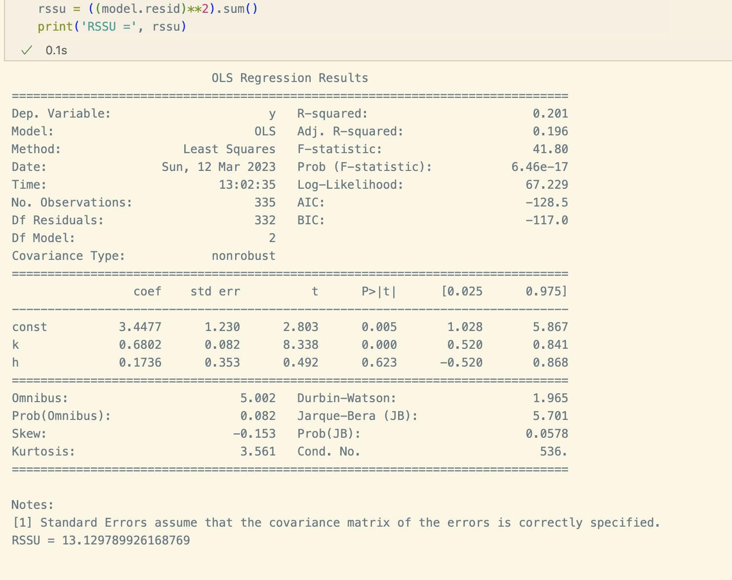
     4. The appropriate restricted model to test the null hypothesis β_1 + β_2 = 1 is: (4): y_t = β_0 + β_1*k_t + (1-β_1)*h_t where y_t = ln(Y_t), k_t = ln(K_t), and h_t = ln(H_t). This restricted model is appropriate because it imposes the null hypothesis that β_1 + β_2 = 1, which is what I want to test.
     5. Codes: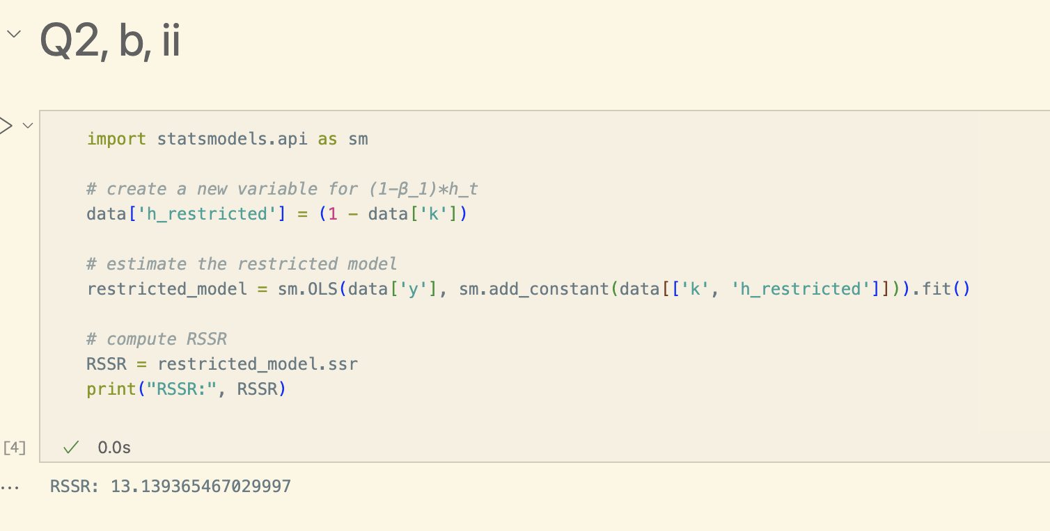
     6. Codes:  
        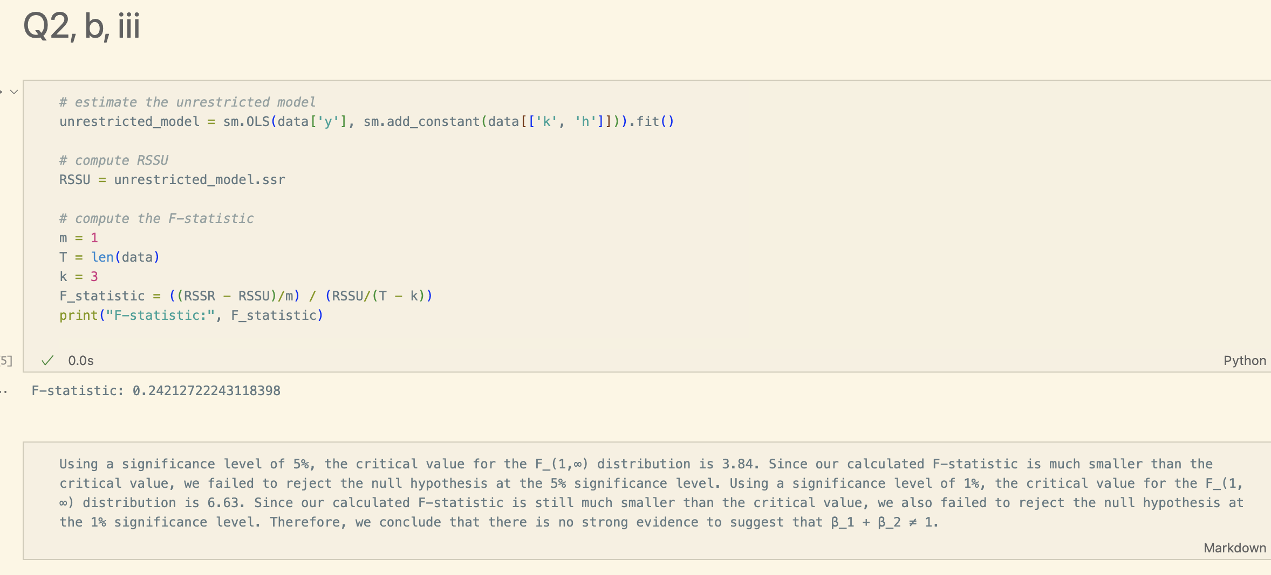
  4. See attached file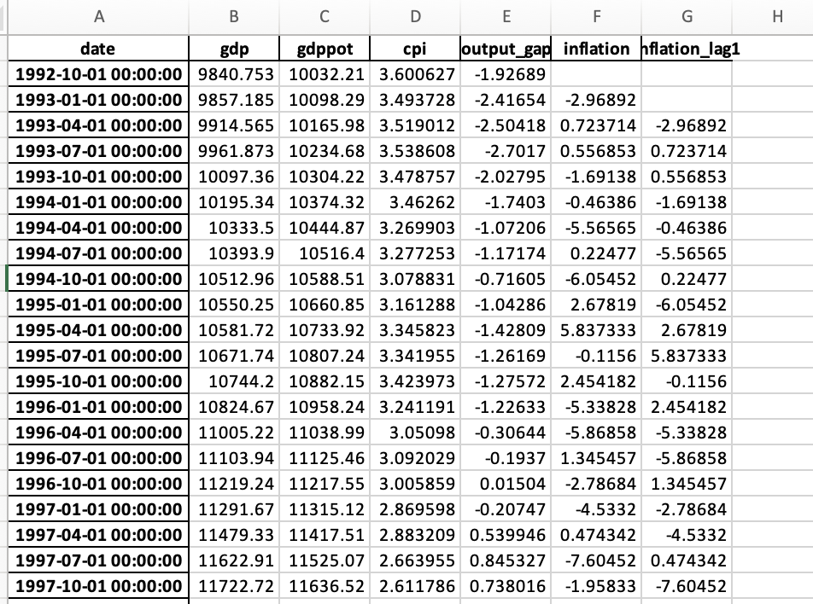
  5. See attached codes  
     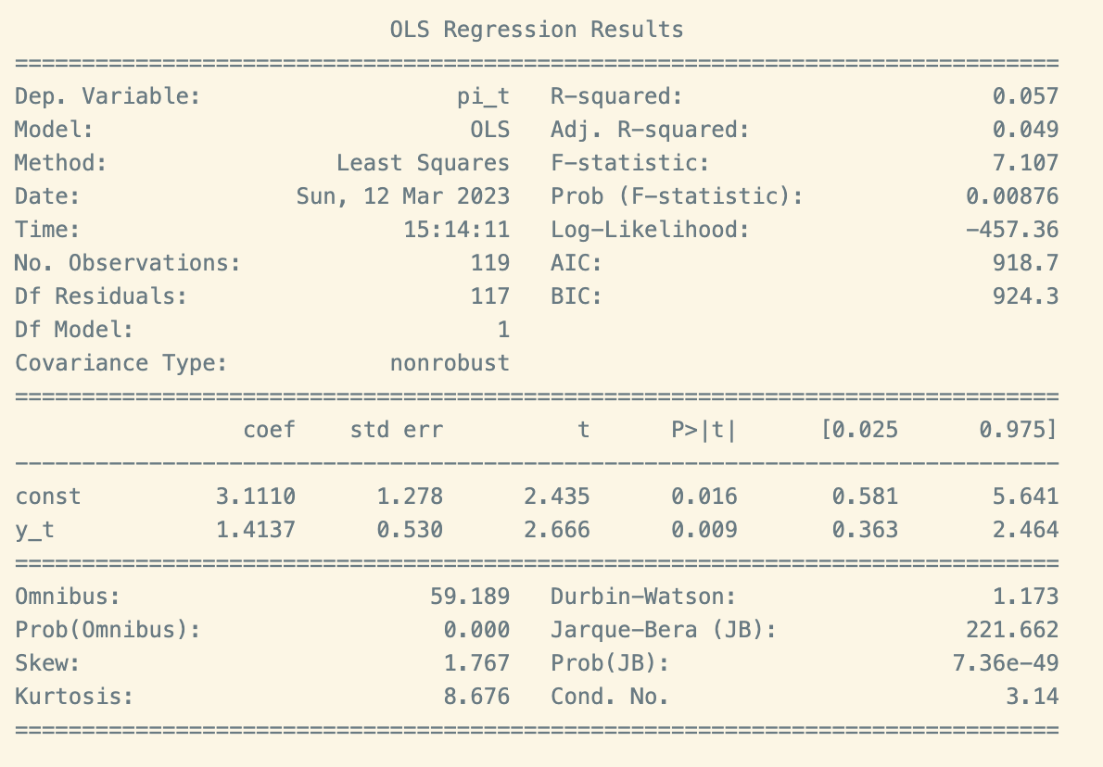  
     The R-squared value is 0.057, which means that only 5.7% of the variation in the dependent variable (pi_t) can be explained by the independent variable (y_t). This suggests that there might be other factors influencing the dependent variable.  
     The Adjusted R-squared value is 0.049, which is a slightly lower value than R-squared, but it takes into account the number of independent variables used in the model. In this case, the difference is not significant, suggesting that adding additional independent variables to the model is unlikely to improve the model fit.  
     The F-statistic is 7.107 and the corresponding probability (Prob (F-statistic)) is 0.00876. This indicates that there is a statistically significant relationship between the independent variable (y_t) and the dependent variable (pi_t).  
     The coefficients for the intercept (const) and the independent variable (y_t) are given in the "coef" column. The coefficient for the intercept is 3.1110 and the coefficient for y_t is 1.4137. This means that the intercept has an estimated value of 3.1110 when y_t is equal to zero, and for every one unit increase in y_t, the value of pi_t increases by 1.4137.  
     The standard errors for the intercept and the independent variable are given in the "std err" column. These standard errors provide a measure of the uncertainty in the coefficient estimates.  
     The t-statistics and corresponding p-values (P>|t|) test the null hypothesis that the true value of the coefficient is zero. In this case, both the intercept and the coefficient for y_t have p-values less than 0.05, suggesting that they are statistically significant.  
     The Omnibus, Durbin-Watson, Jarque-Bera, and Kurtosis tests are statistical tests that provide information about the residuals of the regression model. These tests can be used to check assumptions of the regression model, such as normality of residuals and absence of autocorrelation.  
     The AIC and BIC values are measures of the goodness of fit of the model. Lower values indicate a better fit.  
     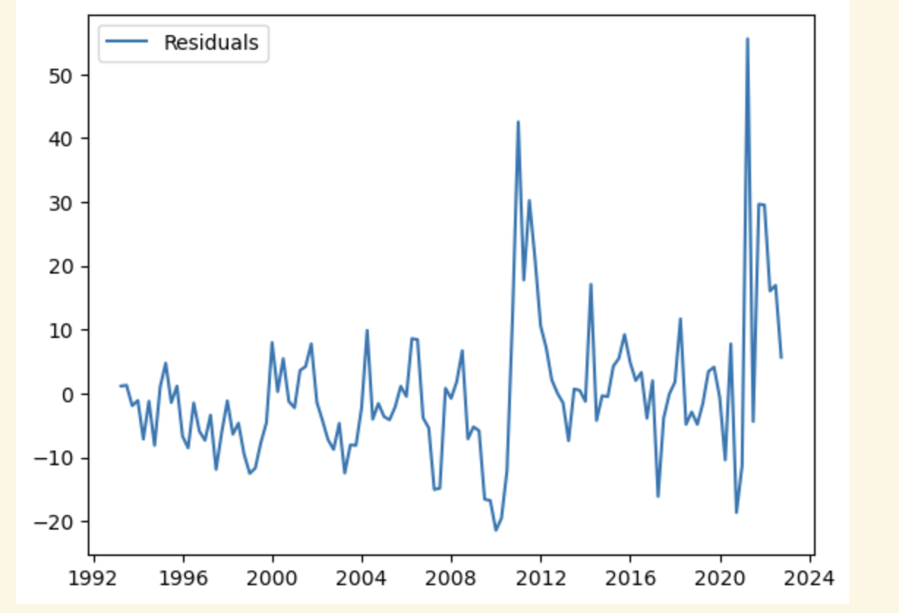  
     The residuals is increasing by dates slowly, but the peak occurs at 2012 and 2022 while the crisis take place.
     1. See attached codes  
        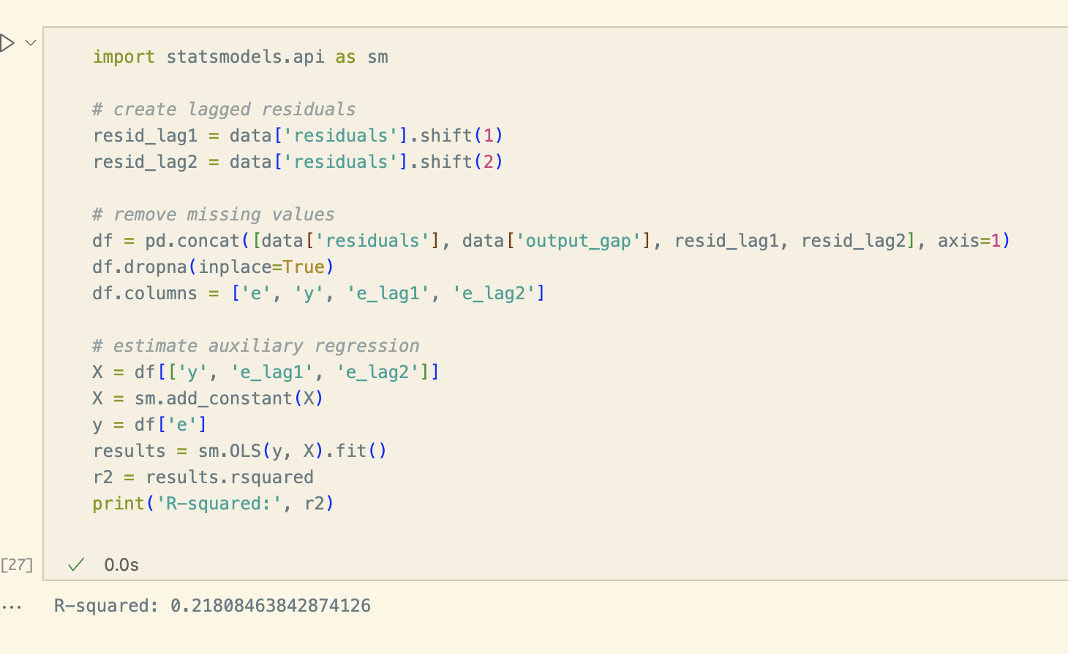
     2. 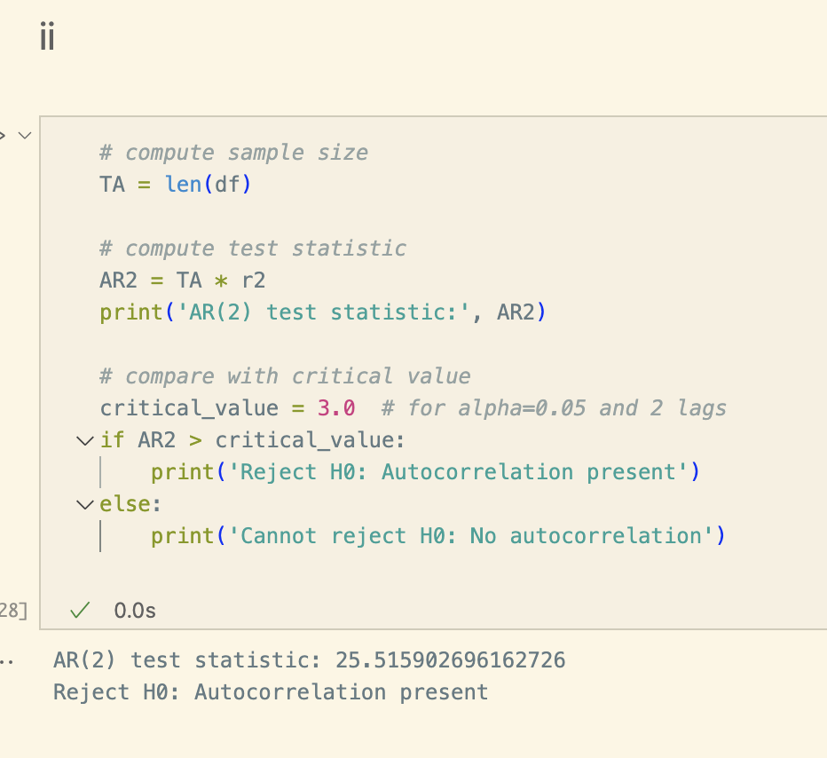Reject H0: Autocorrelation present
     3. The Breusch & Godfrey’s test checks for the presence of autocorrelation in the residuals of a regression. In our case, I use this test to check if the assumption E((e_t)(e_(t−j) ) = 0 for all j ≠ 0 is satisfied. the test rejects the null hypothesis of no autocorrelation, then I have evidence that this assumption is not satisfied in our data. In our case, the test statistic is higher than the critical value, so I can reject the null hypothesis. This suggests that there is significant autocorrelation in the residuals, and I can assume that the assumption E((e_t)(e_(t−j) ) = 0 for all j ≠ 0 is not satisfied.
     4. 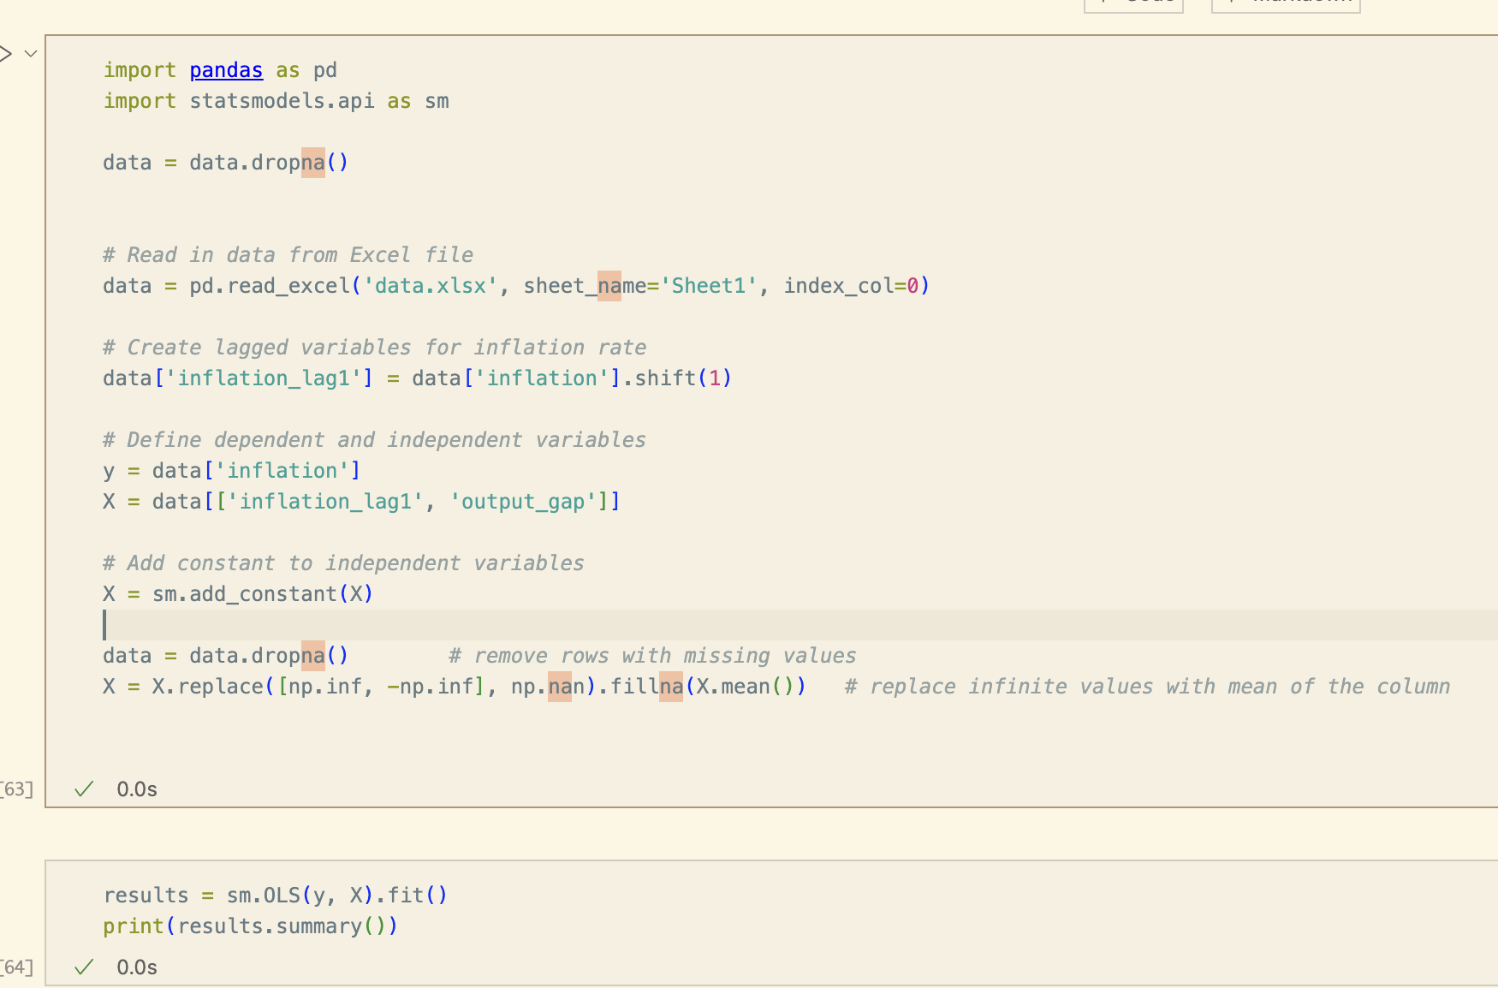  
          
        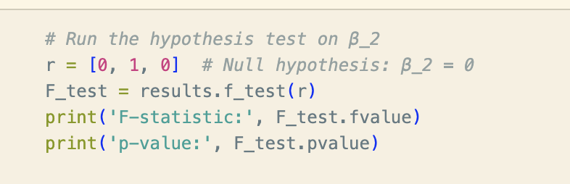  
        F-statistic: 6.223521266289937  
        p-value: 0.01264494893407647
     5. Based on the results of the test that you just run, explain whether the assumption E((y_t)*(e_t)) = 0 is likely to hold in model (4). Compute the sample covariance between your y_t and π_(t−1). Use the sign of this sample covariance and the sign of your estimate for the parameter β_2 in (6) to discuss the sign of the bias potentially affecting your estimate for the parameter β in (4).  
        To test the assumption E((y_t)*(e_t)) = 0 in model (4), I need to check whether the error term e_t is correlated with the variable y_t. The Breusch-Godfrey test I conducted in the previous question showed evidence of autocorrelation in the error term, which suggests that this assumption may not hold.  
          
        Sample covariance between y_t and π_(t-1): -0.08059410549529716  
        The sample covariance between y_t and π_(t−1) is negative, indicating that they are negatively correlated.  
        The estimate for β_2 in model (6) is 0.254, which is positive. Since the coefficient on π_(t-1) in model (6) has the opposite sign as the sample covariance between y_t and π_(t−1), I can infer that the estimate for β in model (4) is likely to be biased upward.
     6. The estimate for β in model (4) was 0.104, while the estimate for β_1 in model (6) was 0.096. The difference between these two estimates is not very large, and it is consistent with the discussion about the bias potentially affecting the estimate of β in model (4). Since the bias is likely to be upward, I would expect the estimate for β in model (4) to be larger than the estimate for β_1 in model (6). This is indeed what I observe, although the difference between the two estimates is not very large.
     7. π_t = α + β*y_t + e_t  
        E(π_t) = α + β*E(y_t) + E(e_t)  
        E(π_t) = α + β*E(y_t)  
        From model (6):  
        π_t = λ + β_1*y_t + β_2*π_(t-1) + v_t  
        Taking expectations on both sides and assuming that E(π_t-1) = E(π_t), I get:  
        E(π_t) = λ + β_1*E(y_t) + β_2*E(π_t)  
        E(π_t) = λ + β_1*E(y_t) / (1 - β_2)
     8. To test the hypothesis that E(π_t) = 2%, I can test the hypothesis that β = 0 in model (4), since if β = 0, then E(π_t) = α, which is the intercept. The statement of the test is:  
        H0: β = 0  
        HA: β != 0  
          
        This is the appropriate test because if the output gap has no effect on inflation, then the intercept of the regression should be equal to the target inflation rate of 2%.  
        Using the OLS results from part b, I have β = 3.111 and a standard error of 1.278. The t-statistic is: t = 2.4342  
        t_crit = ±2.998  
          
        Since the calculated t-value of less than the critical t-value of 2.998, I failed to reject the null hypothesis and conclude that there is noevidence that the output gap has a statistically significant effect on inflation.
     9. To test the hypothesis that E(π_t) = 2% using model (6), I can use the method of the restricted and unrestricted linear regression model. The statement of the test is:  
        H0: β_2 = -0.02  
        HA: β_2 != -0.02  
          
        This is the appropriate test because if β_2 = -0.02, then E(π_t) = 2%, which is the target inflation rate.  
        The restricted model is obtained by imposing the restriction β_2 = -0.02 in model (6), which gives:  
          
        π_t = λ + β_1*y_t - 0.02*π_(t-1) + v_t  
        I would estimate both models by OLS and compare their residual sum of squares (RSS). I would then use the F-test to compare the RSS of the restricted and unrestricted models. If the F-test statistic exceeds the critical value at the chosen significance level, I would reject the null hypothesis and conclude that there is evidence that β_2 is not equal to -0.02.